Low Oil Pressure RTT, Fixed Telltale, & Warning Combined GAS/HEV/Diesel Applications – CGEA1.3

Functional Description

The Low Oil Pressure RTT and the Low Oil Pressure Fixed Telltale are used to inform the driver of an unsafe engine operating condition due to low engine oil pressure. A given vehicle is equipped with either a Low Oil Pressure RTT or a Low Oil Pressure Fixed Telltale and in most cases a Low Oil Pressure warning message.

The Low Oil Pressure RTT and Low Oil Pressure Fixed Telltale correlate the Low Oil Pressure Switch status, Operational_Mode, and Engine Speed to illuminate or extinguish the Low Oil Pressure RTT or Fixed Low Oil Pressure Telltale; and Low Oil Pressure warning message as equipped.

The Oil Pressure Switch input to the Instrument Cluster shall be received either via hardwired A/D input or via CAN message. The Instrument cluster shall be configured for either input. Either input may be available on any given cluster program, but only one input will be on any single vehicle.

The Low Oil Pressure RTT and Fixed Telltale shall provide an iconic representation that will illuminate to inform the driver of an unsafe engine operating condition due to low engine oil pressure and the indicator shall extinguish when a safe engine operating condition exists. The Fixed Telltale is illuminated during Bulb Proveout while the RTT is not.

This section describes the RTT function and sets a flag that is used by the Message Center display (See Message Center Section for details of Message Display Algorithm). This STSS shall be used for ALL low oil pressure RTT and fixed telltale applications and is intended to be compatible with:
- Gas Engine
- Diesel Engine
- HEV including HEV with silent start.
- Engine Stop/Start feature (i.e. Microhybrid)

Important: FOR ALL MARKETS if the text warning in this STSS is implemented without a red RTT then a Fixed LED as per this STSS is REQUIRED to ensure worldwide regulatory compliance. ECE Reg 121 Witness Authority is now rejecting use of Low Oil Pressure related warning texts without a red Low Oil Pressure telltale (RTT or Fixed LED is acceptable). Previously a text warning message could be used without RTT / TT if equipped with an oil pressure gauge with proper identifier symbol, but that is no longer accepted.

Interfaces

Interface Context Diagram (I/O Block Diagram)

Figure 1 Low Oil Pressure Interface Context Diagram
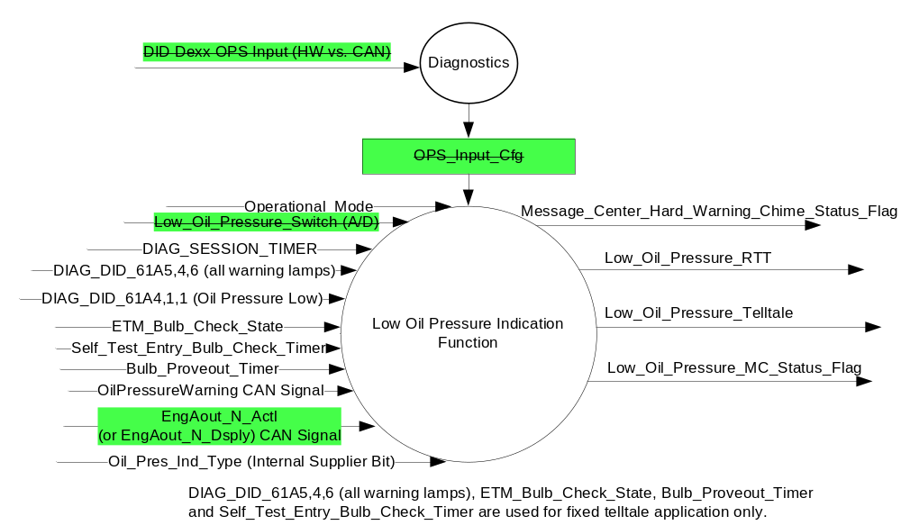

Inputs
      - INTERNAL:
- Operational_Mode
- OPS_Input_Cfg
- Oil_Pres_Ind_Type = Fixed TT (fixed telltale) or RTT (Reconfigurable Telltale/Message)
- Bulb_Proveout_Timer
- EngAout_N_Actl or EngAout_N_Dsply, MUX signal on the CAN Bus. (Follow signal per Tachometer Gauge - CGEA1.3 STSS)
- The Oil Pressure Switch input, which per OPS_Input_Cfg shall be either
- Low_Oil_Pressure_Switch (A/D), hardwired to the cluster
Or
- OilPressureWarning, MUX signal on the Bus

- Input Description for Hardwired Low_Oil_Pressure_Switch (A/D)
Oil Pressure | Oil Pressure Switch State | Oil Pressure Switch Reading | Debounce | Low_Oil_Pressure_Switch  (A/D)
Less than Trip Point | Open | > 1000 ohms to Open circuit | Min 5 samples in a row @ 6-10 ms | > OPS_Trip_Point
Greater than Trip Point | Closed | 1000 ohms to 0 Ohms, inclusive | Min 5 samples in a row @ 6-10 ms | < = OPS_Trip_Point
            - Normally Open Oil Pressure Switch has its contact open when “sitting on the shelf."
            - The highest ohm value (1000 ohm) for the Closed State of the Oil Pressure Switch must result in a Low_Oil_Pressure_Switch <= OPS_Trip_Point for all voltage inputs across the production build. Therefore, the lowest ohm value for the Open State of the Oil Pressure Switch that will result in a Low_Oil_Pressure_Switch > OPS_Trip_Point will vary across the production build. This value must be lower than 1500 ohms across the production build.

- EngAout_N_Actl Signal
Signal Name | Size  (bits) | Detail | Units | Res. | Offset | State Encoded | Min. | Max.
EngAout_N_Actl | 13 |  | RPM | 2 | 0 |  | 0 (0x0) | 16382 (0x1FFF)

- EngAout_N_Dsply Signal (Newer filtered Tach signal)
Signal Name | Size  (bits) | Detail | Units | Res. | Offset | State Encoded | Min. | Max.
EngAout_N_Dsply | 13 |  | RPM | 2 | 0 |  | 0 (0x0) | 16382 (0x1FFF)

- OilPressureWarning Signal
Signal Name | Size  (bits) | Detail | Units | Res. | Offset | State  Encoded | Min. | Max.
OilPressureWarning | 1 |  | SED | 1 | 0 |  | 0 (0x0) | 1 (0x1)
 |  | Normal_Pressure_  Lamp_Off |  |  |  | 0x0
 |  | Low_Pressure_  Lamp_On |  |  |  | 0x1

- Input Arbitration
OPS_Input_Cfg | Debounced Low_Oil_Pressure_Switch  (A/D) | OilPressureWarning  Signal | Oil_Pressure_State  (internal variable)
0x0 (HW) | > OPS_Trip_Point | X | 0x1 (Low)
0x0 (HW) | < = OPS_Trip_Point | X | 0x0 (OK)
0x1 (HS_CAN) | X | 0x0 (OK) | 0x0 (OK)
0x1 (HS_CAN) | X | 0x1 (Low) | 0x1 (Low)
All Other Cases |  |  | 0x1 (Low)

Outputs
Low_Oil_Pressure_Indicator, flag used to identify low oil pressure fault condition is present.
Low_Oil_Pressure_RTT, flag which is used to control the state of the Reconfigurable Telltale
Low_Oil_Pressure_Telltale, flag which is used to control the state of the Fixed Telltale.
Low_Oil_Pressure_MC_Status_Flag, flag which is used to control the state of the Warning Message
and virtual gauge red indication (if equipped).
Message_Center_Hard_Warning_Chime_Status_Flag

Function/Performance

Operational Modes

Mode | Differentiating Vehicle Conditions
Sleep Mode | Low Oil Pressure Indication OFF
Limited Mode | Low Oil Pressure Indication OFF
Normal Mode | Low Oil Pressure Indication ON / OFF
Crank Mode | Low Oil Pressure Indication ON / OFF

The above table references the setting of the control flags as defined in 1.2.3 in this section. The actual RTT display operational modes, however, are displayed in the Message Center section of this SPSS.

Voltage Levels
Refer to the Cluster Features Table located in the Operational Modes and Voltage Range Strategies Section of this SPSS

Human-Machine Interface

Visual

Indicator Graphics / Display Format
Refer to Message center function Description reference "Text Message List - BEF Displays 2x14" Message ID W700

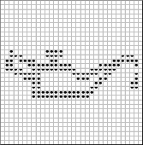



Pixel Definition F.04

For actual symbol definition see pixel definition section in the message center section. The pixel representation is based upon the symbol definition database # F.04 of the 03-0685 ARL requirement

1.3.3.2.1 Indicator Color Coordinates
Red - Reference SDS IL-0017/IS-0379 (Color must be red to insure regulatory
compliance – monochromatic RTT not allowed).

1.3.3.2.2 Indicator Characteristics
Pixel Display in Message Center Display – Low Oil Pressure RTT

Audio
A message center warning chime to be activated as per RTT chime algorithm specified in the message center section of this SPSS.
MC Message Warning ID W700 is associated with Message_Center_Hard_Warning_Chime_Status_Flag
See Table 1.8

Switch Control Logic
None

System Accuracy
The state of the Low_Oil_Pressure_RTT shall change within 100msec of a state change as indicated in the state matrix, reference 1.3.5.1 Subsystem Algorithm Flowchart / State Diagram

Operation: Performance and Functional

Subsystem Algorithm Flowchart / State Diagram
Figure 2 Low Oil Pressure State Transition Diagram
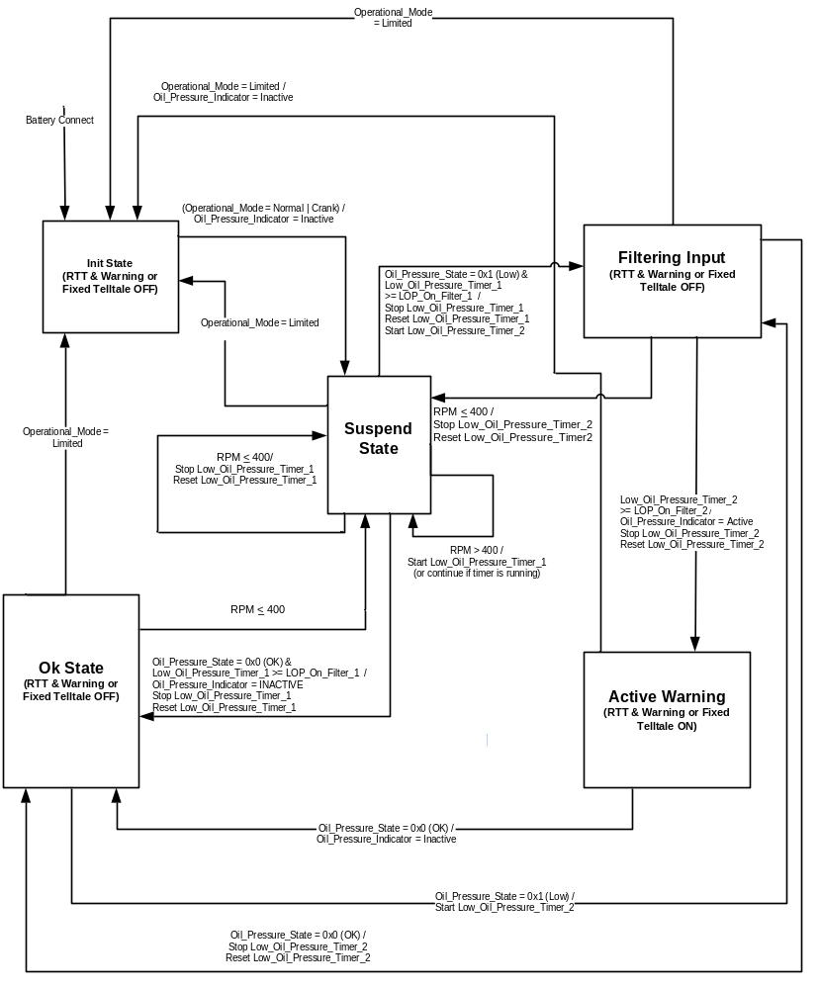

Figure 3 CAN Diagnostic Routine
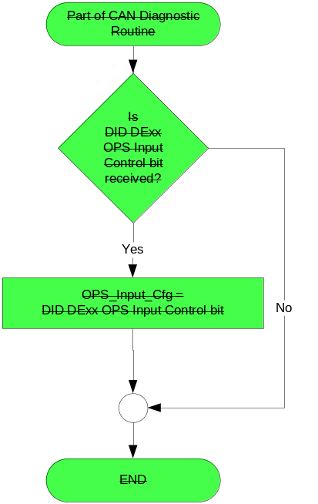

- State Matrix for Low_Oil_Pressure_RTT & Low_Oil_Pressure_Telltale
Operational  _Mode | Oil_Pres  _Ind_Type | ETM_Bulb_  Check_State | Self_Test_ Entry_Bulb_ Check  _Timer | DIAG  _SESSION  _TIMER | DIAG_DID  _61A4,1,1  (Oil Pressure Low) | DIAG_DID  _61A5,4,6  (All Warnings Lamp) | Bulb_  Proveout_  Timer | Oil_Pressure  _Indicator  (Per Figure 2) | Low_Oil  _Pressure  _RTT | Low_Oil  _Pressure  _Telltale | Low_Oil_Pressure  _MC_Status  _Flag
Normal or Crank | RTT | X | X | Not Active | X | X | X | Active | Active | OFF | Active
Normal or Crank | RTT | X | X | Not Active | X | X | X | If CAN Input, signal declared missing as per 1.4.1 | Active | OFF | Inactive
Normal or Crank | Fixed TT | X | X | Not Active | X | X | Active | X | Inactive | ON | Inactive
Normal or Crank | Fixed TT | X | X | Not Active | X | X | X | Active | Inactive | ON | Active
Normal or Crank | Fixed TT | X | X | Not Active | X | X | X | If CAN Input, signal declared missing as per 1.4.1 | Inactive | ON | Inactive
Normal or Crank | Fixed TT | ON (0x1) | X | Not Active | X | X | X | X | Inactive | ON | Inactive
Normal | RTT | X | X | Active | Not Received | X | X | Active | Active | OFF | Active
Normal | RTT | X | X | Active | Not Received | X | X | If CAN Input, signal declared missing as per 1.4.1 | Active | OFF | Inactive
Normal | RTT | X | X | Active | ON (0x1) | X | X | X | Active | OFF | Inactive
Normal | Fixed TT | X | X | Active | Not Received | Not Received | Active | X | Inactive | ON | Inactive
Normal | Fixed TT | X | X | Active | Not Received | Not Received | X | Active | Inactive | ON | Active
Normal | Fixed TT | X | X | Active | Not Received | Not Received | X | If CAN Input, signal declared missing as per 1.4.1 | Inactive | ON | Inactive
Normal | Fixed TT | ON (0x1) | X | Active | Not Received | Not Received | X | X | Inactive | ON | Inactive
Normal | Fixed TT | X | Active | Active | X | X | X | X | Inactive | ON | Inactive
Normal | Fixed TT |  | X | Active | X | ON(0x1) | X | X | Inactive | ON | Inactive
Normal | Fixed TT |  | X | Active | ON (0x1) | X | X | X | Inactive | ON | Inactive
All other Cases |  |  |  |  |  |  |  |  | Inactive | OFF | Inactive
X = Don’t Care
Not Received = The state when DIAG_SESSION_TIMER is active and the DID has not yet been received.

- Telltale Flag to Telltale Mapping
Active Telltale Flag | Low Oil Pressure Telltale
Low_Oil_Pressure_Telltale | ON

- RTT Flag to Telltale Mapping
Active Telltale Flag | Low Oil Pressure RTT
Low_Oil_Pressure_RTT | Active

- MC_Status_Flag Message Center Warning Mapping
Active MC_Status_Flag | MC Warning Message ID | Active Chime_Status_Flag
Low_Oil_Pressure_MC_Status_Flag | W700 | Message_Center_Hard_Warning_  Chime_Status_Flag

Operation Description (supports algorithm flowchart /state diagram)
- The Low_Oil_Pressure_Telltale, Low_Oil_Pressure_RTT, and Low_Oil_Pressure_MC_Status_Flag shall reflect specified operational state within 100 ms of a change in that state, excluding Oil Pressure Switch debounce times.
- Upon direction of Ford D&R engineer (cluster applications) hard wired portion of this STSS need not be implemented. General practice for CGEA will be for cluster to receive oil pressure status via CAN signal. Hardwired input will be the exception but may need to be protected for on a given program.
- Upon direction of Ford D&R engineer (cluster applications) fixed telltale portion of this STSS need not be implemented. Many programs will contain RTT in all cluster levels but certain programs will have to protect for low line cluster with fixed telltale.
- The Low_Oil_Pressure_MC_Status_Flag was added so the warning message is able to be displayed for LED telltale applications on M0/L0 IPC for example. The Low_Oil_Pressure_MC_Status_Flag is also used by the virtual gauge for virtual gauge or other gauge applications where the gauge provides some type of red indication upon low oil pressure warning condition being active.
- Digital switch inputs shall be debounced with a minimum of 5 consecutive samples over period between 30 ms to 50 ms. All samples must be identical in order to assert a new debounced value.
- Typical maximum output delay = 73 msec: 50 msec to debounce input, 20 msec to process it and 3 msec to indicate switch status.
- The actual RTT display operational modes are displayed in the Message Center Section of this SPSS.
- Important: FOR ALL MARKETS if the text warning in this STSS is implemented without a red RTT then a Fixed LED as per this STSS is REQUIRED to ensure worldwide regulatory compliance.

Function Safety Classification (EMC)
Class B

Memory Storage
Parameter Name | Description | Value at  Battery Connect | Value at  Module  Wake-up | Value at Transition to Normal l Crank From Limited Mode
Low_Oil_Pressure_Indicator | Used to control the state of the Oil Pressure RTT and Telltale Flags | Inactive (0x0) | Inactive (0x0) | Inactive (0x0)
Low_Oil_Pressure_RTT | Used to control the state of the RTT | Inactive (0x0) | Inactive (0x0) | Inactive (0x0)
Low_Oil_Pressure_Telltale | Used to control the state of the Fixed Telltale | OFF(0x0) | OFF(0x0) | OFF(0x0)
Low_Oil_Pressure_MC  _Status_Flag | Used to control the state of the warning message and virtual gauge color. | Inactive (0x0) | Inactive (0x0) | Inactive (0x0)
Low_Oil_Pressure_Switch (A/D) | Controlled by the value of the switch trip point | Closed (0x0) | Closed (0x0) | Closed (0x0)
OPS_Input_Cfg | State Indicator defining input for Oil Pressure Switch information. Configured via CAN at VO EOL. Defaulted to 0 (HW) at cluster manufacturing location.  (0x0) = HW, (0x1) = HSCAN | Use Stored Value | Use Stored Value | Use Stored Value
OilPressureWarning signal | Oil Pressure Switch Input from PCM or ECM | Low_Pressure_  Lamp_On (0x1) | Low_Pressure_  Lamp_On (0x1) | Low_Pressure_  Lamp_On (0x1)
Oil_Pressure_State | Internal cluster variable used to correlate input config, HW and CAN OPS inputs into an arbitrated variable | 0x1 (Low) | 0x1 (Low) | 0x1 (Low)
EngAout_N_Actl signal or EngAout_N_Dsply signal | Engine RPM used in RTT State determination | 0 (0x0) | 0 (0x0) | 0 (0x0)
ETM_Bulb_Check_State | State indicator for warning bulb in ETM | OFF (0x0) | OFF (0x0) | OFF (0x0)
Operational_Mode | 4 state indicator for cluster operational mode | Limited | Limited l Normal l Crank | Normal l Crank
Low_Oil_Pressure_Timer _1 | Timer used to control exit from Suspend State | Reset | Reset | Reset
Low_Oil_Pressure_Timer _2 | Timer used to control exit from Filtering Input State. | Reset | Reset | Reset
Bulb_Proveout_Timer | Internal command directing proveout | Not Active | Not Active | Active
Oil_Pres_Ind_Type | Internal variable to indicate the LOP indicator as Fixed TT (Telltale) or RTT | Hardware Dependant | Do Not Init | Do Not Init
Message_Center_Hard_Warning_  Chime_Status_Flag | Used to control the state of the chime to the Chime Arbitrator | Inactive | Inactive | Inactive

Parameter Name | Description | Range | Units | Resolution | Init Value
LOP_On_Filter_1 | Time value used to filter from an ok state to a warning state | 0 – 127 | Seconds | 0.5 | 6.5
LOP_On_Filter_2 | Time value used to filter from an ok state to a warning state | 0 – 127 | Seconds | 0.5 | 3.5
OPS_Trip_Point | A/D value for 1000 ohm input @ 9volts in OPS circuit | 0-255 | A/D | 1 | Hardwired Design Dependent

Prove Out

3.0 +/- 0.1 seconds as per bulb prove out section for Fixed Telltale only. Cluster controls prove out as per Table 1.4 in section 1.3.5.1. No DTCs shall be logged while in Prove Out.

Reconfigurable Telltale

Yes

Message Center Msg
Warning Message ID W700, as defined in the Text Message List section of this SPSS.

See Message Center Section for strategy of displaying RTT based upon state of the RTT flag.

Error Handling

Missing Message Strategy

The signals will be declared missing as per the Diagnostics section of this SPSS.

DTCs states and history will be determined as per the Diagnostics section of this SPSS.

If the message associated with OilPressureWarning signal is declared missing as per the
Diagnostic section of this SPSS then Low_Oil_Pressure_Indicator shall default to Active.

If the message associated with EngAout_N_Actl or EngAout_N_Dsply signal is declared missing as per the
Diagnostic section of this SPSS then signal shall default to RPM > 400.

Diagnostics

Self Test

None

Engineering Test Mode

Reference section “Dealer / Engineering Test Mode (ETM)”

Part II Performance

Supported Diagnostic Trouble Codes (DTCs)

DTC | Description
C10000 | Lost Communication With ECM/PCM "A"

Supported Diagnostic DIDs (Service $22 and $2F)
Number | DID / CommonID Name | DID Type
61A4 | Warning Lamp Status 1, byte 1, bit 1 (Oil Pressure Low) | Bit Mapped
61A5 | Warning Lamp Status 2, byte 4, bit 6 (All Warnings Lamp) | Bit Mapped

DID DExx
Bits | State: Description | "0" | "1" | Default | Comments/  Information
1 | Oil Pressure Switch (OPS) Input | Hardwired | CAN | CAN | All CGEA 1.3 programs should be “CAN”  **********************************  SET THIS TO “1” FOR ALL CGEA 1.3 PROGRAMS TO PROTECT LEGACY CLUSTERS THAT STILL SUPPORT THIS CONFIG.  BIT IS BEING OBSOLETED.  *********************************
*Byte and bit location to be identified in Part II Specification for this cluster

Reference Specification
DE-0042 OIL PRESSURE WARNING INDICATOR
EN-0090 OIL PRESSURE WARNING INDICATOR

IS-0001 WARNINGS/INDICATORS/DISPLAYS PROVEOUT
IS-0046 INSTRUMENTATION MATERIAL RESISTANCE TO CLEANING
IS-0052 OPERATING VOLTAGES - FUNCTIONAL/PERFORMANCE
IS-0069 FUNCTIONAL IMPORTANCE CLASS
IS-0324 WINDSHIELD & OTHER REFLECTIONS
IS-0327 WARNING INDICATOR EVALUATION
IS-0329 FLICKERING OF LAMPS
IS-0379 NORTH AMERICAN WARNINGS AND INDICATORS STRATEGY

IL-0017 TELLTALE AND INTERIOR ILLUMINATION COLOR
IL-0021 CRAFTSMANSHIP - DISPLAYS
IL-0023 CLARITY/LEGIBILITY/READABILITY
IL-0025 INTERIOR ILLUMINATION INTENSITY
IL -0027 VISUAL CONTRAST
IL -0043 OPERATIONAL ENVIRONMENT FUNCTIONALITY
IL -0045 COLOR
IL -0047 TELLTALE; INDICATOR AND DISPLAY LIGHT INTENSITY
IL -0048 ILLUMINATION ACCEPTABILITY

03-0661 PLACEMENT: CONTROL AND DISPLAY LOCATIONS
03-0662 PLACEMENT: LOGICAL GROUPING FUNCTION AND USAGE
03-0664 PLACEMENT: DOWN VISION TO COMPONENTS WITH HIGH VISUAL DEMAND
03-0665 PLACEMENT: EXPECTED LOCATIONS OF CONTROLS AND DISPLAYS VDS
03-0670 INTERIOR VISIBILITY
03-0671 INTERIOR VISIBILITY: REFLECTIONS FROM COMPONENTS & SURFACES
03-0672 INTERIOR VISIBILITY: REFLECTIONS IN DISPLAYS
03-0673 INTERIOR VISIBILITY: VISUAL OBSCURATIONS
03-0674 INTERIOR VISIBILITY: ILLUMINATION CONTROLS / DISPLAYS
03-0675 INTERIOR VISIBILITY: VEILING GLARE
03-0677 INTERIOR VISIBILITY: SUNLIGHT WASHOUT
03-0681 IDENTIFICATION: CHARACTER AND SYMBOL SIZE
03-0682 IDENTIFICATION: LEGIBILITY
03-0685 IDENTIFICATION: SYMBOLS, ABBREV FOR CONTROL
03-0721 LOGIC OF OPERATION: OPERATIONAL STEREOTYPES
03-0722 LOGIC OF OPERATION: INTERPRETATION
03-0723 LOGIC OF OPERATION: USE OF SYSTEMS WITH VISUAL DISPLAYS

Revision History
SPSS Module Revision History
Revision Level | Name | Change Description | Date
1.0 | V. Patel | Updated for CGEA 1.3 based on CGEA STSS v2.0  Section 1.2.2 – Removed table referencing the HS-CAN message that contains the input signal.  Section 1.4 – Rewritten. Deleted references of specific missing message flags and timer.  Section 1.5.3 – Deleted DTC logging criteria from the table. | 4/12/2010
2.0 | Jblatchf | This update adds a second timer which allows the cluster to set an initial filter time which is longer than the normal operating filter time. It also is compatible with HEV and vehicles with start/stop feature as it will not set the warning at less than 400RPM. If the RTT becomes active due to low oil pressure condition (RPM>400) this strategy will also hold the RTT active during subsequent HEV electric drive mode and between start stop events provided the oil pressure remains low.  1.1 Added application note  Figure 1: Revised Diag inputs  1.2.2 Removed Diag inputs.  Table 1.6 Removed  Figure 2: Updated.  1.3.3.2 Added " Refer to Message center function Description reference "Text Message List - BEF Displays 2x14" Message ID W700" to section  1.3.5.2 Removed comment relative to 3.5s delay.  Added note regarding hardwired input.  1.3.5.4 Removed Diag rows.  Added note relative to diesel applications.  1.5.3 Added DID DE00 table. | 9/17/2010
3.0 | Jblatchf | This update adds fixed telltale application.  - Updated  1.2.1 Updated  1.2.3 Updated  Table 1.4 Added  1.3.5.2 Added note regarding fixed Telltale  1.3.5.4 Added new flags. | 9/29/2010
3.1 | Jblatchf | This update commonizes diesel and gas applications – Changes Lop_On_Filter_1 value to 6.5s for both gas and diesel.  1.3.5.4:  Low_Oil_Pressure_Timer_1, Low_Oil_Pressure_Timer_2: corrected typo in description.  LOP_On_Filter_1: Removed 3.5s timer value and ref to gas/diesel.  Removed note below table relative to gas/diesel. | 12/15/2010
3.2 | Jblatchf | Figure 2: Removed condition on data flow from the Init State box to the Suspend State box. Condition inadvertently left in diagram from draft version. Removed description of RTT/Fixed Telltale state from the Init Box. | 1/21/2011
3.3 | T. Cwik | Update to correct for missing Diagnostic DID and incorrect State Matrix  Section 1.2.1 – Figure 1 – Added DID 61A4,1,1 and 61A5,4,6, deleted PID 6308 and Bulb_Proveout_Timer and updated CAN input OilPressureWarning  Section 1.3.5.1 – Added Figure 3 and completely rewrote Table 1.4  Section 1.3.5.4 – Added Oil_Pres_Ind_Type  Section 1.5.3 –  – Changed DTC to C10000  – Updated from DE00 to DExx  – Added Supported Diagnostic DIDs Table containing 61A4, 61A5 | 9/17/2013
3.4 | J. Blatchford | This change clarifies usage without RTT. DCR not required unless warning text is implemented without RTT or TT – Otherwise new programs only.  1.1: Added last paragraph. Modified second to last paragraph.  1.3.3.1.2: Added note relative to color.  1.3.5.2: Added bottom 2 notes. | 10/9/2013
4.0 | T. Cwik | This change adds back in the Bulb Proveout that was mistakenly removed in _v3.3. Bulb Proveout is now needed since Key Run Engine Off condition does not result in an active RTT.  Section 1.1 – Added “The Fixed Telltale is illuminated…”  Section 1.2.1 – Figure 1 – Added Bulb_Proveout_Timer  Section 1.2.2 – Added Bulb_Proveout_Timer  Section 1.3.5.1 – Table 1.4 – Added two rows for Active Bulb_Proveout_Timer  Section 1.3.5.4 – Added Bulb_Proveout_Timer  Section 1.3.5.5 – Rewrote entire section | 1/12/2015
4.1 | J. Blatchford | This change adds the Low_Oil_Pressure_MC_Status_Flag which is used to trigger the low oil pressure warning message which will allow applications which employ a fixed LED telltale to display the low oil pressure warning message. The Low_Oil_Pressure_MC_Status_Flag is also used as an input to the Oil Pressure Gauge for virtual gauge or other applications where the gauge turns red (resolution do Denso P558 Q&A #443. Except for Figure 1 changes highlighted in yellow.  - 1.0: Added Warning to title.  - 1.1: Added text relative to warning message.  - Figure 1: Added MC_Status_Flag.  - 1.2.3: Added output flag. Corrected Indicator Flag.  - Table 1.4: Added column.  - Tables1,5,1.6,1.7: Added tables for clarity.  - 1.3.5.2: Added bullet point. Updated first bullet point.  - 1.3.5.4: Added output. | 3/6/15
5.0 | S. Watkins | It is no longer necessary to protect for a hardwired OPS input to the cluster. Therefore, we are removing the config. Furthermore, the UP375 team managed to wrongly configure this input. Thus, we are also removing the input config to prevent any future configuration mistakes for this feature.  Also, there is a new filtered CAN RPM signal that is being phased into programs for the tachometer. The CAN signal used for the tachometer should also be used for this STSS. Thus, have also updated this STSS to allow use of EngAout_N_Dsply. (legacy signal is EngAout_N_Actl)  All changes highlighted in green.  - All references to HW input deleted.  - RPM signal updated to allow EngAout_N_Dsply | 10/14/2015
5.1 | Ilopezla | This update add the Chime_Status_Flag associated to this warning  Section 1.2.1 Figure 1 Added Message_Center_Hard_Warning_Chime_Status_Flag  Section 1.2.3 Added Message_Center_Hard_Warning_Chime_Status_Flag  Section 1.3.3.3 Added Message_Center_Hard_Warning_Chime_Status_Flag  Section 1.3.5 Updated Table 1.8  Added Active Chime_Status_Flag Column  Added Message_Center_Hard_Warning_Chime_Status_Flag  Section 1.3.5.4 Added Message_Center_Hard_Warning_Chime_Status_Flag Row | 12/17/2015

